To install the apk file

Download the apk file of the mobile app and keep at the shared location

Path - E:\jar_files_selenium\Mobile Automation_Appium\mobileapkfiles\cris.org.in.prs.ima.apk

Run the command through command prompt

adb install “E:\jar_files_selenium\Mobile Automation_Appium\mobileapkfiles\cris.org.in.prs.ima.apk”

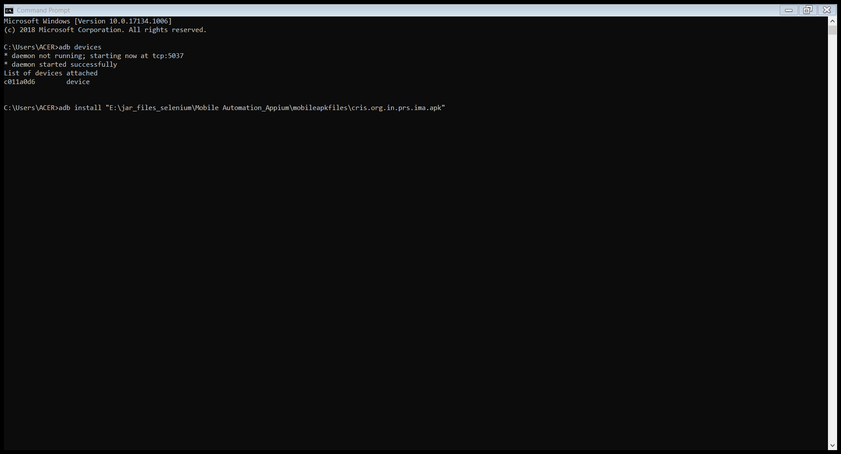

E:\jar_files_selenium\Mobile Automation_Appium\mobileapkfiles\ com.google.android.calculator.apk

TO start the apium server using command prompt

Type appium from anywhere (from any drive )

